**Hackathon Project Phases Template** for the **AutoSage App** project.

Hackathon Project Phases Template

# Project Title:

**Audio transcription app using OpenAi Whisper**

# Team Name:

EchoScribe

# Team Members:

* S. Srinija
* K. Sidhartha Rao

# Phase-1: Brainstorming & Ideation

## Objective:

Develop an AI-powered audio transcription tool for accurate and efficient speech-to-text conversion.

## Key Points:

1. **Problem Statement:**
   * Many users struggle with transcribing audio recordings accurately and efficiently.
   * Existing transcription tools may have limitations in handling different accents, languages, and background noise.
   * Users need a reliable, fast, and cost-effective solution for converting speech to text.
2. **Proposed Solution:**
   * An AI-powered transcription application leveraging **OpenAI Whisper** for high-accuracy speech recognition.
   * Support for multiple languages and accents to improve accessibility.
   * Options for real-time transcription and batch processing of recorded audio**.**
   * User-friendly interface for uploading, processing, and downloading transcriptions.
3. **Target Users:**
   * **Students & Researchers:** Transcribing lectures and interviews.
   * **Journalists & Content Creators:** Converting interviews and podcasts into text**.**
   * **Business Professionals**: Generating meeting notes and summaries**.**
   * **Individuals with Accessibility Needs**: Assisting those who prefer text-based communication.
4. **Expected Outcome:**
   * A **functional, accurate, and efficient** transcription tool powered by OpenAI Whisper.
   * Seamless **speech-to-text conversion** with options for text formatting and exporting.
   * User satisfaction through a **smooth and intuitive UI experience**.

# Phase-2: Requirement Analysis

## Objective:

Define the technical and functional requirements for the Transcription App.

## Key Points:

1. **Technical Requirements:**
   * Programming Language: **Python**
   * Backend: **Flask, Hugging Face**
   * Frontend: **HTML, CSS**
   * Database: **Sqllite3**
2. **Functional Requirements:**
   * Allow users to upload audio files for transcription.
   * Process and convert audio into text using OpenAI Whisper.
   * Provide options for different transcription models (e.g., base, large).
   * Enables copying the transcribed text.
3. **Constraints & Challenges:**
   * Ensuring enough computation power for using the whisper large with a size of 1.85B parameterd.
   * Providing a **smooth UI experience** with HTML.

# Phase-3: Project Design

## Objective:

Develop the architecture and user flow of the application.

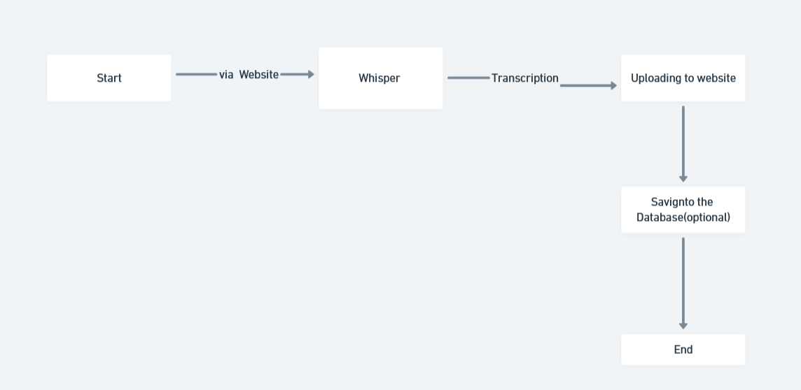

## Key Points:

1. **System Architecture:**
   * User uploads an audio file or records audio via the UI.
   * The request is processed using **OpenAI Whisper API** for transcription.
   * The AI model transcribes the speech into text with high accuracy.
   * The frontend displays the transcribed text, with options to edit, copy, or download.
2. **User Flow:**
   * **Step 1:** User uploads an audio file or records live audio.
   * **Step 2:** The backend processes the file using **OpenAI Whisper** for transcription.
   * **Step 3:** The transcribed text is displayed in a clean and readable format.
   * **Step 4:** Users can edit, format, or download the text as needed.
3. **UI/UX Considerations:**
   * **Minimalist, user-friendly interface for seamless navigation.**
   * **Progress indicator while transcription is in process.**
   * **Support for multiple languages and different accents.**
   * **Dark & light mode for a better user experience.**
   * **Download options (TXT, DOCX, or PDF).**

# Phase-4: Project Planning (Agile Methodologies)

## Objective:

Break down development tasks for efficient completion.

|  |  |  |  |  |  |  |  |
| --- | --- | --- | --- | --- | --- | --- | --- |
| **Sprint** | **Task** | **Priority** | **Duration** | **Deadline** | **Assigned To** | **Dependencies** | **Expected Outcome** |
| Sprint 1 | Environment Setup & API Integration | 🔴 High | 6 hours  (Day 1) | End of Day 1 | Srinija | Python, model setup | Model is loaded & working |
| Sprint 1 | Frontend UI Development | 🟡  Medium | 2 hours  (Day 1) | End of Day 1 | Sidhartha | Response format finalized | Basic UI with input fields |
| Sprint 2 | Vehicle Search & Comparison | 🔴 High | 3 hours  (Day 2) | Mid-Day 2 | Sidhartha | UI elements ready | Search functionality with filters |
| Sprint 2 | Error Handling & Debugging | 🔴 High | 1.5 hours  (Day 2) | Mid-Day 2 | Srinija | Model logs | Improved  Model stability |
| Sprint 3 | Testing & UI Enhancements | 🟡  Medium | 1.5 hours  (Day 2) | Mid-Day 2 | Entire Team | UI layout completed | Responsive UI, better user experience |
| Sprint 3 | Final Presentation & Deployment | 🟢 Low | 1 hour  (Day 2) | End of Day 2 | Entire Team | Working prototype | Demo-ready project |

## Sprint Planning with Priorities

**Sprint 1 – Setup & Integration (Day 1)**

**(**🔴 **High Priority)** Set up the **environment** & install dependencies.

**(**🔴 **High Priority)** Integrate **OpenAI Whisper**.

**(**🟡 **Medium Priority)** Build a **basic UI with input fields**.

## Sprint 2 – Core Features & Debugging (Day 2)

**(**🔴 **High Priority)** Implement **search & comparison functionalities**. **(**🔴 **High Priority)** Debug API issues & handle **errors in queries**.

## Sprint 3 – Testing, Enhancements & Submission (Day 2)

**(**🟡 **Medium Priority)** Test API responses, refine UI, & fix UI bugs.

**(**🟢 **Low Priority)** Final **demo preparation & deployment**.

# Phase-5: Project Development

## Objective:

Implement core features of the Trancription App.

## Key Points:

1. **Technology Stack Used:**
   * **Frontend:** HTML, CSS
   * **Backend:** Transformers,Flask
   * **Programming Language:** Python
2. **Development Process:**
   * Implement **API key authentication** and integrate **OpenAI Whisper API** for transcription.
   * Develop **audio processing logic** to handle different formats (MP3, WAV, etc.).
   * Optimize transcription **accuracy and speed** using appropriate Whisper models.
   * Implement **text formatting options** (e.g., punctuation, paragraph structuring).
3. **Challenges & Fixes:**
   * **Challenge:** Large file sizes may slow down processing.

**Fix:** Implement file size limits and allow background processing.

* + **Challenge:** Handling different accents and background noise.

**Fix:** Use **Whisper’s advanced models** and allow **user feedback** to improve results.

# Phase-6: Functional & Performance Testing

## Objective:

Ensure that the AutoSage App works as expected.

|  |  |  |  |  |  |
| --- | --- | --- | --- | --- | --- |
| **Test Case ID** | **Category** | **Test Scenario** | **Expected Outcome** | **Status** | **Tester** |
| TC-001 | Functional Testing | Input of the Audio file | The Transcription of the audio | ✅ Passed | Srinija |
| TC-002 | Functional Testing | Audio with background noise. | Output is perfect a the audio given. | ✅ Passed | Sidhartha |

|  |  |  |  |  |  |
| --- | --- | --- | --- | --- | --- |
| TC-003 | Performance Testing | Response time is based  on the model if we use  the large model it higher | Model should be pipelined for getting results quickly. | ⚠ Needs Optimization | Sidhartha |
| TC-004 | Bug Fixes & Improvements | Fixed incorrect  response. | Data accuracy should be improved. | ✅ Fixed | Srinija |
| TC-005 | Final Validation | Ensure UI is responsive across devices. | UI should work on mobile & desktop. | ✅ Passed | Sidhartha |
| TC-006 | Deployment Testing | Not yet deployed | Website should be deployed | Not Deployed | Srinija |

# Final Submission

1. **Project Report Based on the templates**
2. **Demo Video (3-5 Minutes)**
3. **GitHub/Code Repository Link**
4. **Presentation**